OFDM Report/Presentation Plan:

Section 1: History, Motivation and Description of OFDM (Shuihan):

1 - Defining FDM.

2 - Problems with FDM traditionally.

3 - Motivation for OFDM.

Difference between OFDM and FDMA

4 - Defining Orthogonality.

5 - Defining OFDM (Schematic View).

~15 mins/2-3 pages in report ^^

**OFDM**

**(Orthogonal Frequency Division Multiplexing)**

History, Motivation and Description of OFDM:

**1. Definition of FDM:**

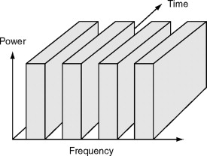

Figure 1. FDM assigns multiple sub-channels.

(Adapted from<https://www.sciencedirect.com/topics/engineering/frequency-division-multiple-access> )

FDM, (Frequency-division multiple access) allows multiple users to send data through a single communication channel, it divides the bandwidth of the channel into separate non-overlapping frequency sub-channels in order to make each signal can be transmitted separately. So, each user can have a sub-channel by modulating the frequency.

**2 - Problems with FDMA traditionally.**

1. Only modest capacity improvements could be expected from a given spectrum allocation.
2. If an FDMA channel is not in use, it is wasted and can not be used by anyone else.
3. FDMA has higher cell site system costs since it uses a costly bandpass filter to eliminate spurious radiation at the base station.
4. On a mobile FDMA unit, it uses duplexers because the transmitter and receiver will work simultaneously and it adds weight, size and cost to it.
5. FDMA requires tight RF filtering to minimize adjacent channel interference(ACI).

Side notes:

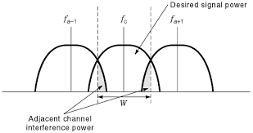

ACI:

The signal which is adjacent in frequency to the desired signal will cause ACI, this signal can pass the bandpass filter because it is a nearby frequency.

This can be reduced by :

1. Using modulation schemes which have low out-of-band radiation
2. Redesign the bandpass filter at the receiver end.
3. Assign adjacent channels to different cells in order to keep the frequency separation between each channel in a given cell as large as possible.
4. Use advanced techniques that employ equalizers.
5. The maximum bit rate of each channel is fixed and small.

**3 - Motivation for OFDM.**

OFDM is a multicarrier digital communication scheme to solve the uses like combining a large number of low data rate carriers to construct a composite high data rate communication system.

**Key features of OFDM:**

1. Multiple carriers (called subcarriers) carry the information stream.
2. The subcarriers are orthogonal to each other.
3. A guard interval is added to each symbol to minimize the channel delay spread and intersymbol interference.

**4 - Defining Orthogonality.**

OFDM is a specialized frequency-division multiplexing (FDM) method, with the additional constraint that all subcarrier signals within a communication channel are orthogonal to one another.

OFDM requires very accurate frequency synchronization between the receiver and the transmitter; with frequency deviation the subcarriers will no longer be orthogonal, causing *inter-carrier interference* (ICI) (i.e., cross-talk between the subcarriers).

**How to synchronize:**

1. Synchronization process

The synchronization process starts when the downlink transmission period is happening, Each mobile terminal uses a pilot signal to undergo frequency and timing estimation. The synchronization process reduces synchronization errors within a tolerable range.The predicted parameters on each user can further detect the downlink data stream and synchronization references for the uplink transmission

1. Frequency and timing estimation

Before this step, frequency and timing estimation is performed in the uplink, the separation of users are performed prior to the synchronization procedure which can be achieved with an efficient subcarrier assignment algorithm.

1. Timing and frequency correction

After the accomplishment of the uplink estimation for timing and frequency offsets, the restoration for the orthogonality among subcarriers will be employed in a similar way at the base station.

**Advantage of Orthogonality:**

1. Save bandwidth: Spectrum efficiency

Using close-spaced overlapping sub-carriers, a significant OFDM advantage is that it makes efficient use of the available spectrum.

1. Immunity to selective fading

One of the main advantages of OFDM is that is more resistant to frequency selective fading than single carrier systems because it divides the overall channel into multiple narrowband signals that are affected individually as flat fading sub-channels.

1. Resilience to interference

Interference appearing on a channel may be bandwidth limited and in this way will not affect all the sub-channels. This means that not all the data is lost.

1. Resilient to ISI (inter-symbol interference)

Another advantage of OFDM is that it is very resilient to inter-symbol and inter-frame interference. This results from the low data rate on each of the sub-channels.

1. Resilient to narrow-band effects

Using adequate channel coding and interleaving it is possible to recover symbols lost due to the frequency selectivity of the channel and narrow band interference. Not all the data is lost.

1. Simpler channel equalisation

One of the issues with CDMA systems was the complexity of the channel equalisation which had to be applied across the whole channel. An advantage of OFDM is that using multiple sub-channels, the channel equalization becomes much simpler.

**Disadvantage of Orthogonality:**

1. High peak to average power ratio

An OFDM signal has a noise like amplitude variation and has a relatively high large dynamic range, or peak to average power ratio. This impacts the RF amplifier efficiency as the amplifiers need to be linear and accommodate the large amplitude variations and these factors mean the amplifier cannot operate with a high efficiency level.

1. Sensitive to carrier offset and drift

Another disadvantage of OFDM is that it is sensitive to carrier frequency offset and drift. Single carrier systems are less sensitive.

**5 - Defining OFDM (Schematic View).**

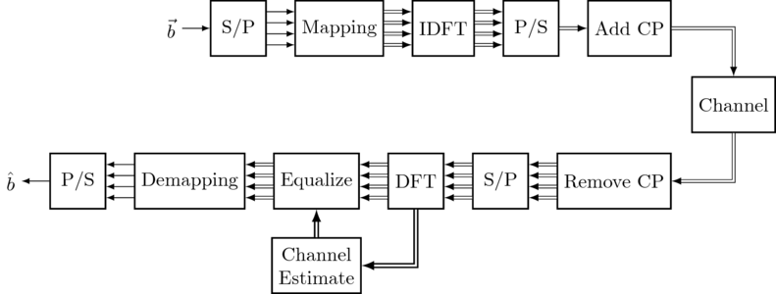

**6 - Phase shift**

Transmitting a signal at high [modulation rate](https://en.wikipedia.org/wiki/Modulation_rate) through a band-limited channel can create [intersymbol interference](https://en.wikipedia.org/wiki/Intersymbol_interference) (ISI). As the modulation rate increases, the signal's bandwidth increases. When the signal's bandwidth becomes larger than the channel bandwidth, the channel starts to introduce distortion to the signal. This distortion usually manifests itself as intersymbol interference.

The signal's spectrum is determined by the modulation scheme and data rate used by the transmitter, but can be modified with a pulse shaping filter. Usually the transmitted symbols are represented as a time sequence of [dirac delta](https://en.wikipedia.org/wiki/Dirac_delta) pulses. This theoretical signal is then filtered with the pulse shaping filter, producing the transmitted signal.

Not every filter can be used as a pulse shaping filter. The filter itself must not introduce intersymbol interference — it needs to satisfy certain criteria.

Examples of pulse shaping filters that are commonly found in communication systems are:

* [Sinc](https://en.wikipedia.org/wiki/Sinc_function) shaped filter
* [Raised-cosine filter](https://en.wikipedia.org/wiki/Raised-cosine_filter)
* [Gaussian filter](https://en.wikipedia.org/wiki/Gaussian_filter)

Sender side pulse shaping is often combined with a receiver side [matched filter](https://en.wikipedia.org/wiki/Matched_filter) to achieve optimum tolerance for noise in the system. In this case the pulse shaping is equally distributed between the sender and receiver filters. The filters' amplitude responses are thus square roots of the system filters.

The other thing is . Other approaches that eliminate complex pulse shaping filters have been invented. In [OFDM](https://en.wikipedia.org/wiki/OFDM), the carriers are modulated so slowly that each carrier is virtually unaffected by the bandwidth limitation of the channel.

Spectrally contained OFDM-based waveforms are considered key enablers for a flexible air interface design to support a broad range of services and frequencies as envisaged for 5G mobile systems. By allowing for the flexible configuration of physical layer parameters in response to diverse requirements, these waveforms enable the in-band coexistence of different services. One candidate from this category of waveforms is pulse-shaped OFDM, which follows the idea of subcarrier filtering while fully maintaining the compatibility with CP-OFDM.

Reference:

<https://en.wikipedia.org/wiki/Frequency-division_multiple_access>

<https://en.wikipedia.org/wiki/Orthogonal_frequency-division_multiplexing#Orthogonality>

<https://dspillustrations.com/pages/posts/misc/python-ofdm-example.html>

https://en.wikipedia.org/wiki/Phase-shift_keying

**Section 2:** Role of Cyclic Prefix, in more detail: (addition from last presentation), (Mohamed)

1 - Guard band in time.

2 - Explain frequency selective channels.

3 - Modelling frequency selective channel as FIR filter.

4 - Cyclic Prefix allows a linear convolution to become a circular convolution.

5 - Using properties of DFS.

6 - This allows for one tap channel equalization.

~10-15 mins/2-3 pages in report ^^

Section 3: Code showing OFDM (Code from last presentation with a few minor additions).